Created by: David Rubio G.
Blog: https://soceame.wordpress.com/
GitHub: https://github.com/DRubioG
Last modification date: 11/03/25

In this post I will discuss the most interesting buffers that Libero incorporates.
- BIBUF: this is a simple bidirectional buffer.
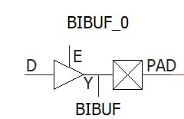
- BIBUF_DIFF: this is a differential bidirectional buffer.
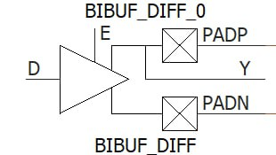
- CLKBUF_DIFF: this is a differential clock input buffer.
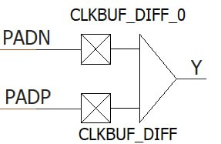
- GCLKBUF_DIFF: this is a global clock buffer, with differential input.
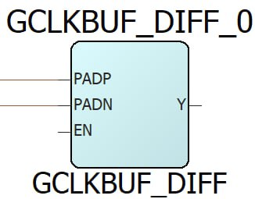
- INBUF_DIFF: this is a differential input and simple output buffer.
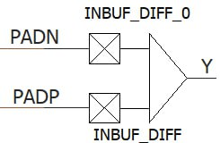
- OUTBUF_DIFF: this is a simple input and differential output buffer.
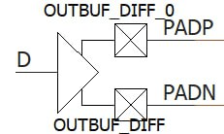
- TRIBUFF_DIFF: this is a simple input and differential output buffer, with enable input.
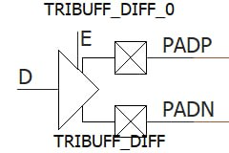
- GCLKBUF: this is a clock buffer with external input and with enable signal.
It can be used as a clock enable signal.
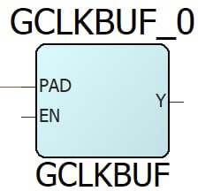
- CLKBIBUF: this is a bidirectional clock buffer.
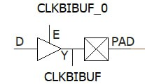
- CLKBUF: This is a clock buffer, as input it has a clock coming from the outside world.
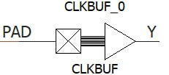
- TRIBUFF: This is an output buffer with an enable signal.
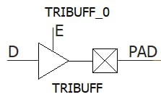
- INBUF: This is an input buffer.
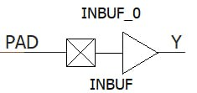
- OUTBUF: This is an output buffer.
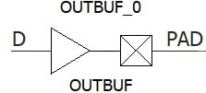

Reference
- Polarfire Macros

